**RxJS (Reactive extensions)**

* Reactive Programming 🡪 This is an asynchronous programming paradigm concerned with data streams and propagation of events. Our software is built to “react” to the changes that user do like click events, data being fetched etc., instead of doing what we are asking it to do via code by writing each event handling separately.
* Reactive eXtensions in JavaScript 🡪 This is library for reactive programming using observables that makes it easier asynchronous or event-based calls.
* RxJS consists of three main features:
  + Observables
  + Satellite types (Observers, Subject, Schedulers.)
  + Operators
    - Array Methods like map(), reduce(), filter() etc.
* These above help us in data streams
* Observables: These emit data over a period of time. These will be subscribed by observers.
* Observer: An observer names has three methods: next (), error (), complete ()
* Operators: Operators help us in writing clean code and reduce lot of effort in writing custom logic. It’s a pure function and have no side effects. Most operators takes observable as input and returns an observable too.

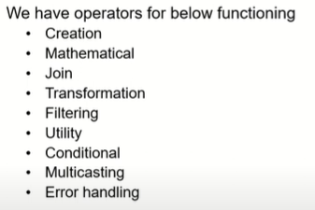

* + **of**: When ever we want to convert an array, string or an object to an Observable we use ‘Of’ operator.
  + **from**: It creates an observable from an array, an array like object, promise object, iterator object and observable like object.
  + **fromEvent**: It converts an event into an observable.
  + **interval**: It returns an Observable that emits an infinite sequence of numbers with a constant interval of time of our choosing. Interval(1000) 🡪 means emits infinite numbers with each being 1 second apart.